# GUI User Manual

Prerequisites:

* Matlab R2018b or later with
* Windows 7/10
* The following files:

1. Bez4StmpGUI.m
2. Bez4StmpGUI.fig
3. BezCP.m
4. Bez4Stmp.m
5. Irit2igs.exe

Manual:

Using Matlab, open and run the file “*Bez4StmpGUI.m*”. The following figure will open:

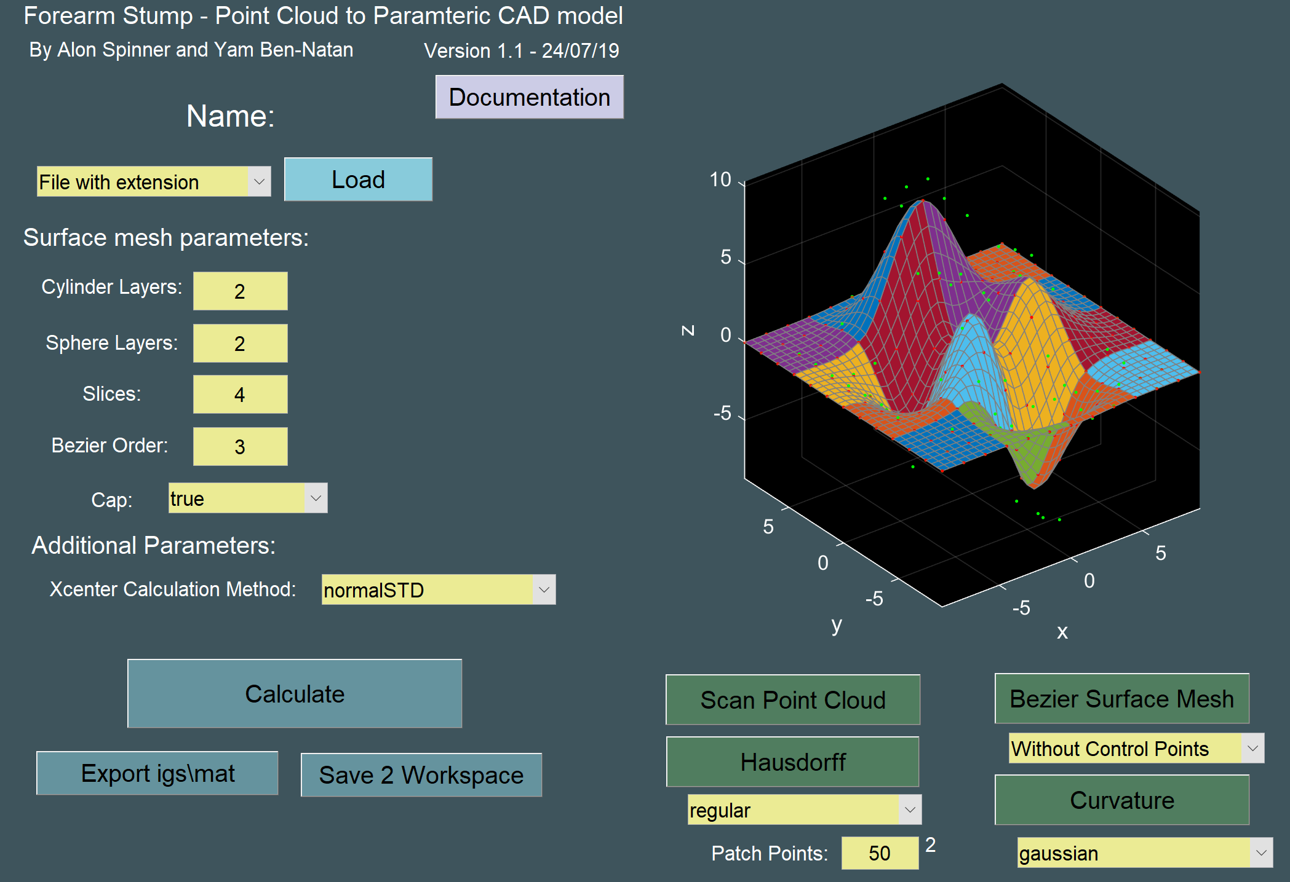

Use the “*Load”* button to load a forearm stump scan from a file or from MATLAB’s base workspace.  
The file of format *“.m”* or workspace variable need tocontain a point cloud data in [x,y,z] double matrix of size or a MATLAB *pointCloud* object. A file of *“. stl”* format is also acceptable.  
Alternatively, you can also load saved work from a previous session using this button.

The loaded point cloud will now appear on the GUI’s axes.

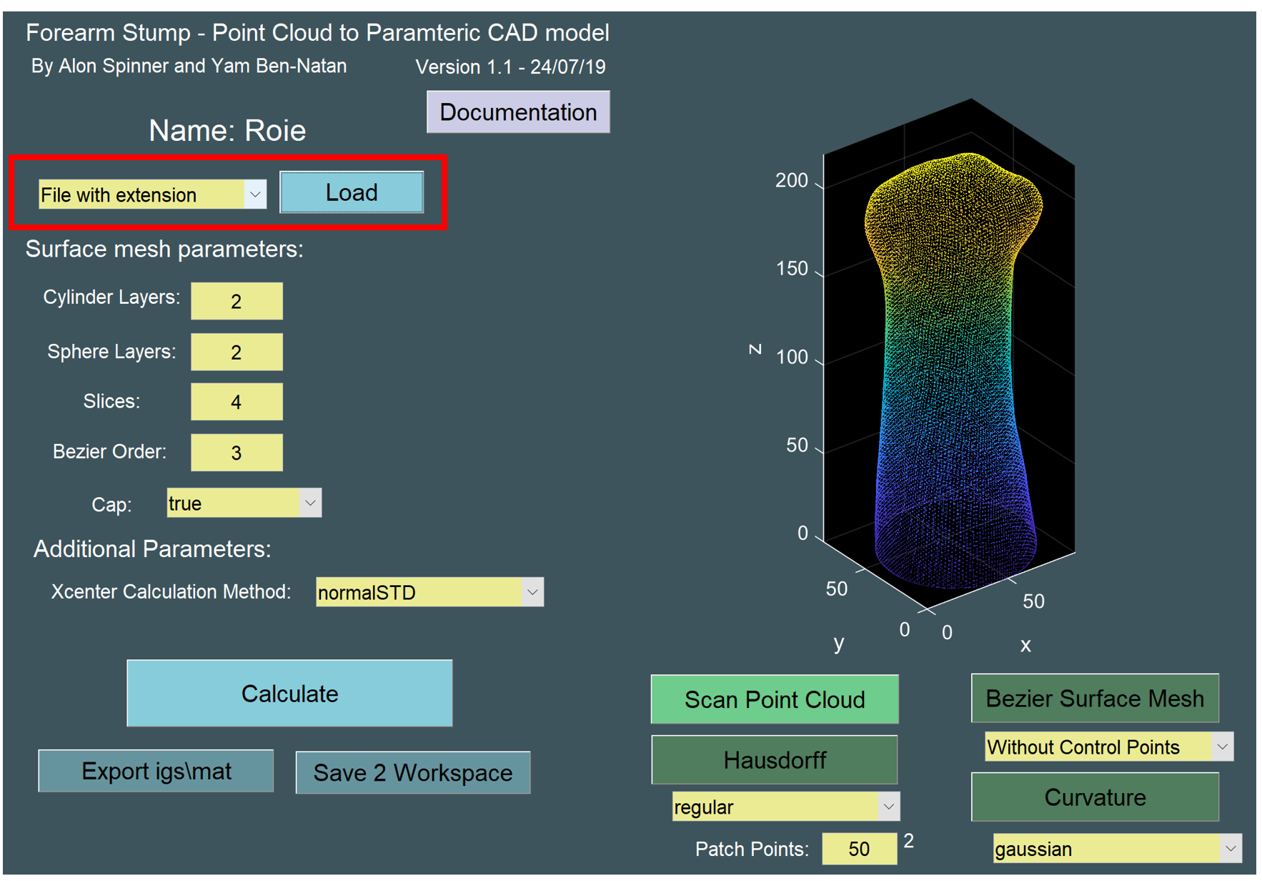

Decide on the Bezier surface mesh parameters.

* Layers and Slices  
  The Bezier surface mesh will be created with reference to the stump’s geometry.  
  The bottom part of the mesh will first be approximated by a synthetic cylinder, and the top by a synthetic sphere.   
  The number of patches in each of those sections is determined by the number of layers and slices.   
  Layers and Slices refer to a cake model. Layers – height direction and slices – radial direction.
* Bezier Order  
  The Bezier order of all patches is the same, and in both direction.  
  Order 3 is recommended.
* Cap  
  Closing the mesh with a patch on the forearm’s peak or by conjoining the top sphere layer into a single point.
* Xcenter Calculation Method  
  Xcenter is the point which separates the cylindrical part and the spherical part in computations. “*NormalSTD”* is the recommended method. User input is also possible.

After choosing the parameters, click *“Calculate”*.   
The computation may take anywhere from 2 minutes to days depending on chosen parameters.  
With the parameters chosen in the figure above, and an Intel processor i7-8705G @3.10 GHz the computation was done in 29 seconds.

When completed, the approximated surface mesh will appear on the GUI’s axes, and functional buttons which required a calculated surface mesh will lit up.

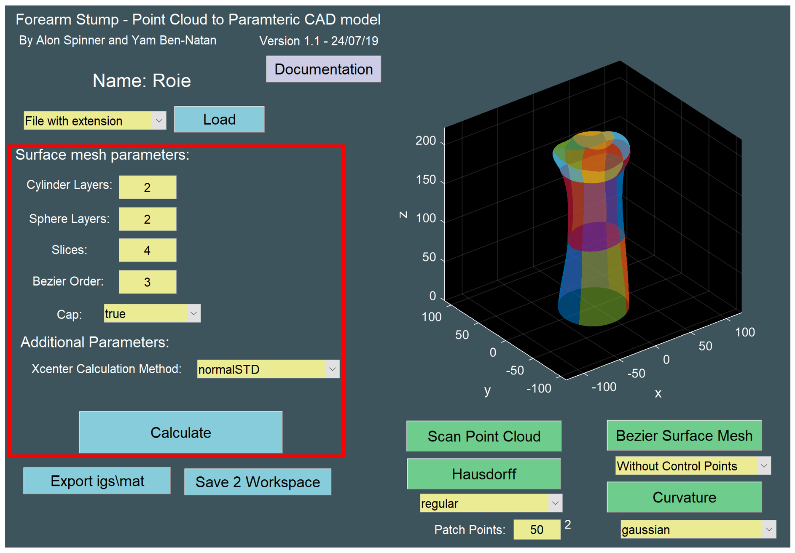

For both curvature calculation and Hausdorff distance map, it is crucial that the user decide on the amount of points per patch. The amount of points can be changed in the yellow edit box on the button right of the GUI’s figure.  
Having a denser mesh will improve the results on the expense of computation time. The created patch points are equidistance in the parameters domain.

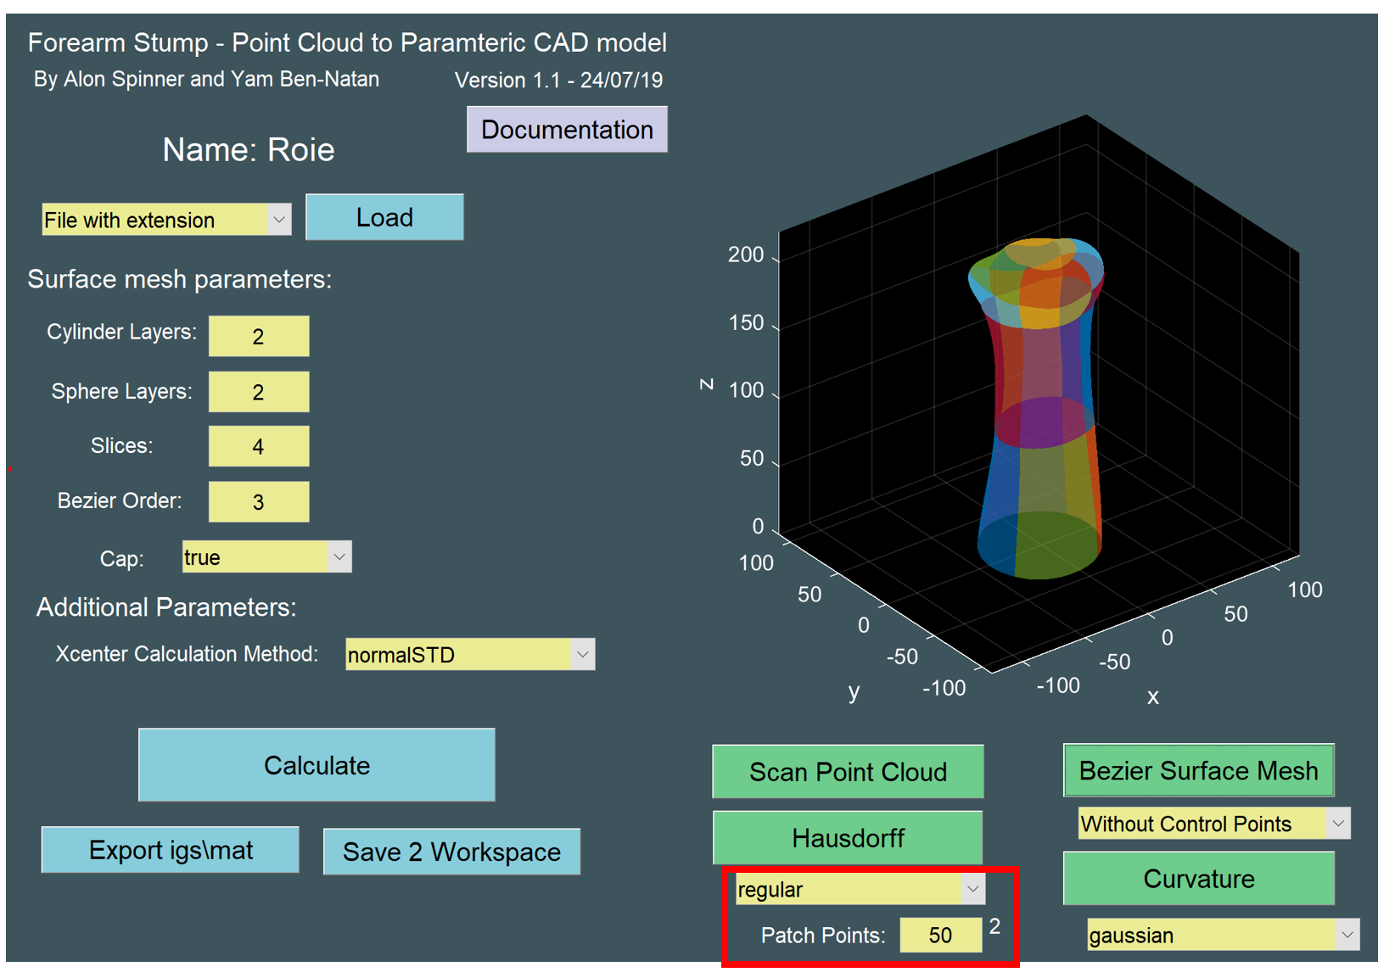

It is possible to draw both mean and gaussian curvature of the stump by pressing on the *“Curvature”* button after choosing the relevant option beneath it.

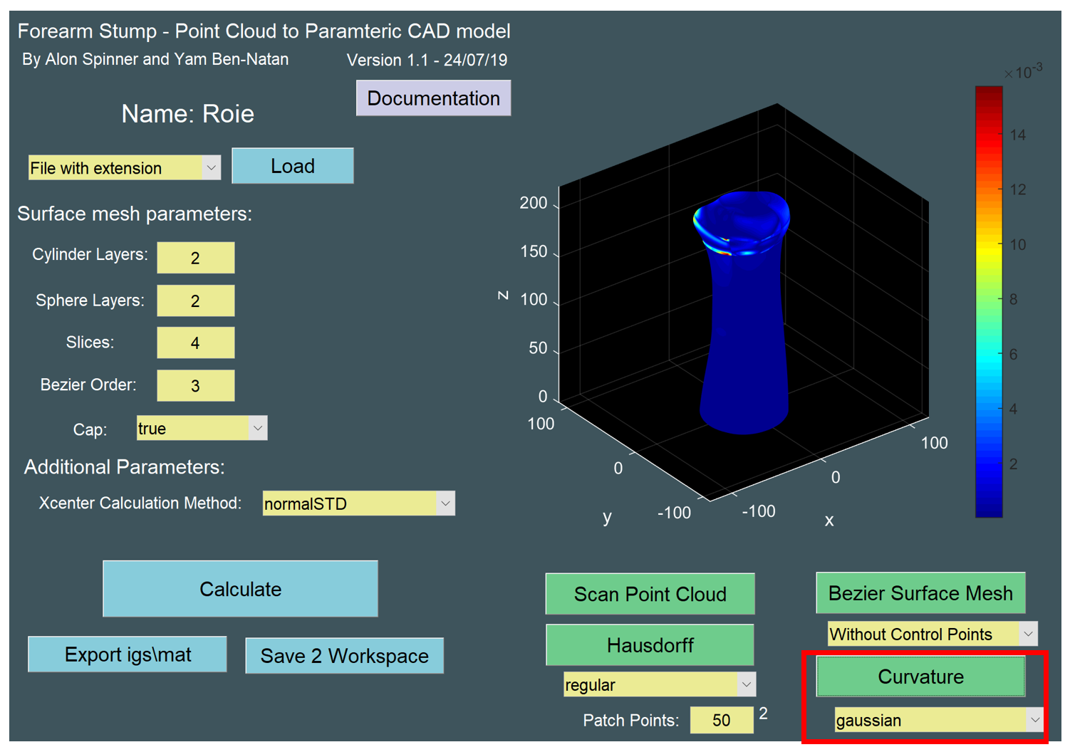

The “*Hausdorff”* button can be used to map a Hausdorff distance function ontop the mesh surface.  
Two options are available – regular and radial.  
The radial option projects the regular Hausdorff distance on the radial direction to obtain the significant error number. The radial option will always show smaller numbers than the regular method.  
The radial direction is chosen differently for each point depending on its location in the modeled geometry, but essentially relates to the cylinder and sphere approximations.

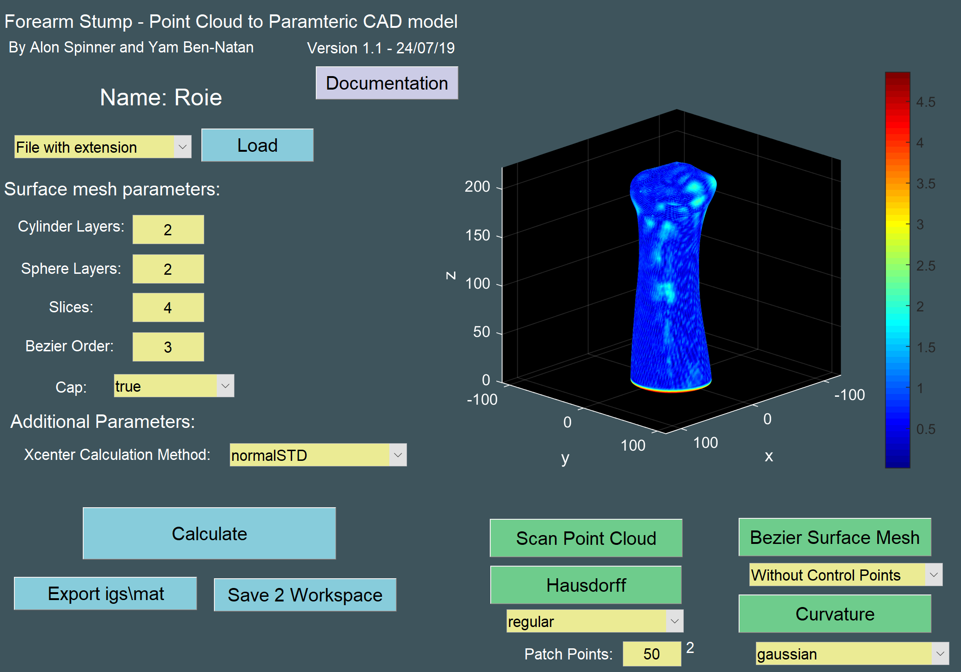

To conclude your work, you can save the calculated data to the MATLAB’s base workspace to be or you can export it using the *“Export igs\mat”* button to be loaded later via the “*Load”* button.  
Also, you can use the *“Export igs\mat”* to create an *“.igs”* file of the Bezier surface mesh in a desired location.  
*“.igs”* files can be opened by most known commercial CAD program such as solidworks.

